P1

Feature Description

People of different ages have different cognitions and different demands

Provide features that meet with variable demands

All age groups!

4 User Stories

P2

Use Case 1

Name: A

Gender: girl

Age: 6

Situation: kindergarten, learn the world

Gain: sense of rhythm

knowledge of classical music

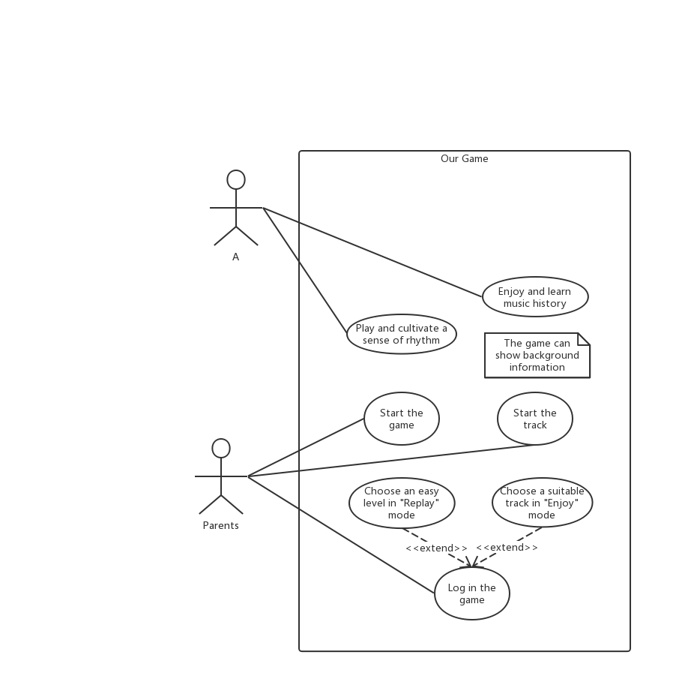

P3

Use Case 2

Name: B

Gender: boy

Age: 16

Situation: grade 10 middle school, want to play games in spare time

Gain: interest of classical music

deeper knowledge of Mozart

fun of RPG and development game (养成游戏)

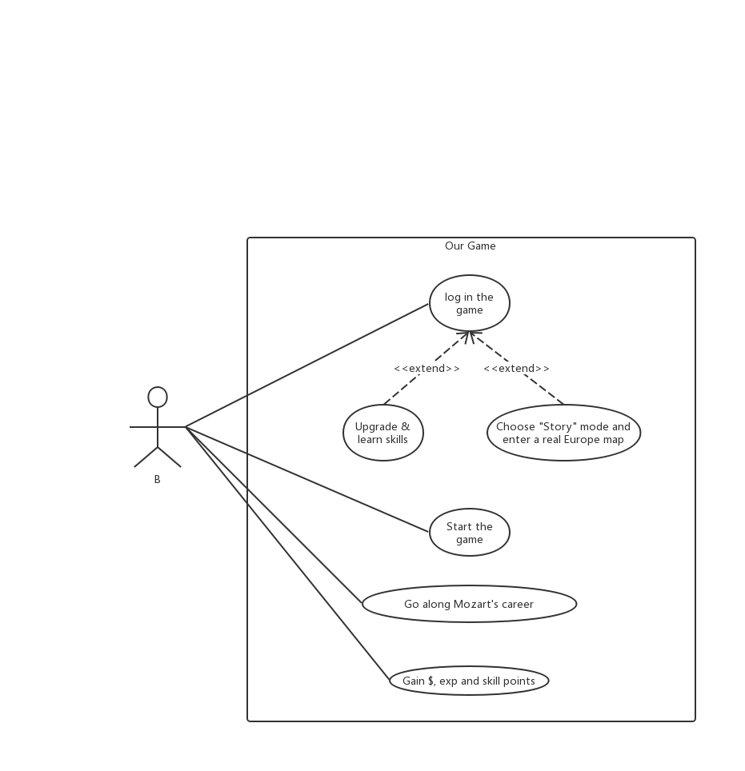

P4

Use Case 3

Name: C

Gender: male

Age: 30

Situation: office clerk, heavy workload

Gain: relax

delight of challenge

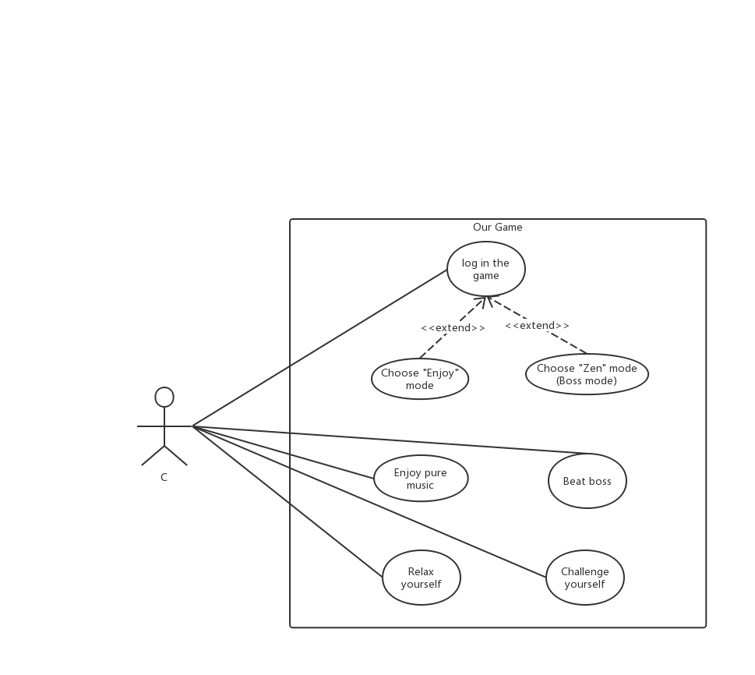

P5

Use Case 4

Name: D

Gender: female

Age: 65

Situation: retired, boring, decreased memory and responsiveness

Gain: enjoy music as the elders always do

prevent Alzheimer

